|  |
| --- |
| genweb2 ltd. |
| Samuda User Manual |
| REFERENCE: GW/ERP/USER MANUAL |
|  |
| **Genweb2 Ltd.** |
| **10-Jul-17** |

|  |
| --- |
| logo.png  **Genweb2 Limited**  TK Bhaban (11th Floor),  13 KaziNazrul Islam Avenue,  Kawran Bazar, Dhaka 1215, Bangladesh  web: [http://www.genweb2.com](http://www.genweb2.com/) |

Contents

1. User Login 3

1.1 Home Page 3

1.2 Login Page 3

1.3 Log out Page 4

1.4 Edit Profile and Change Password 4

1.5 Website Browse and Back to Home Page 6

2. Leave Request 7

2.1 Create Leave Request 7

2.2 Show Leave Summary 9

2.3 Create Leave Allocation Request 10

# 1. User Login

## 1.1 Home Page

For user login we have to go website home page by using URL: 202.164.208.130:8069. Click sign in button and find out login page.

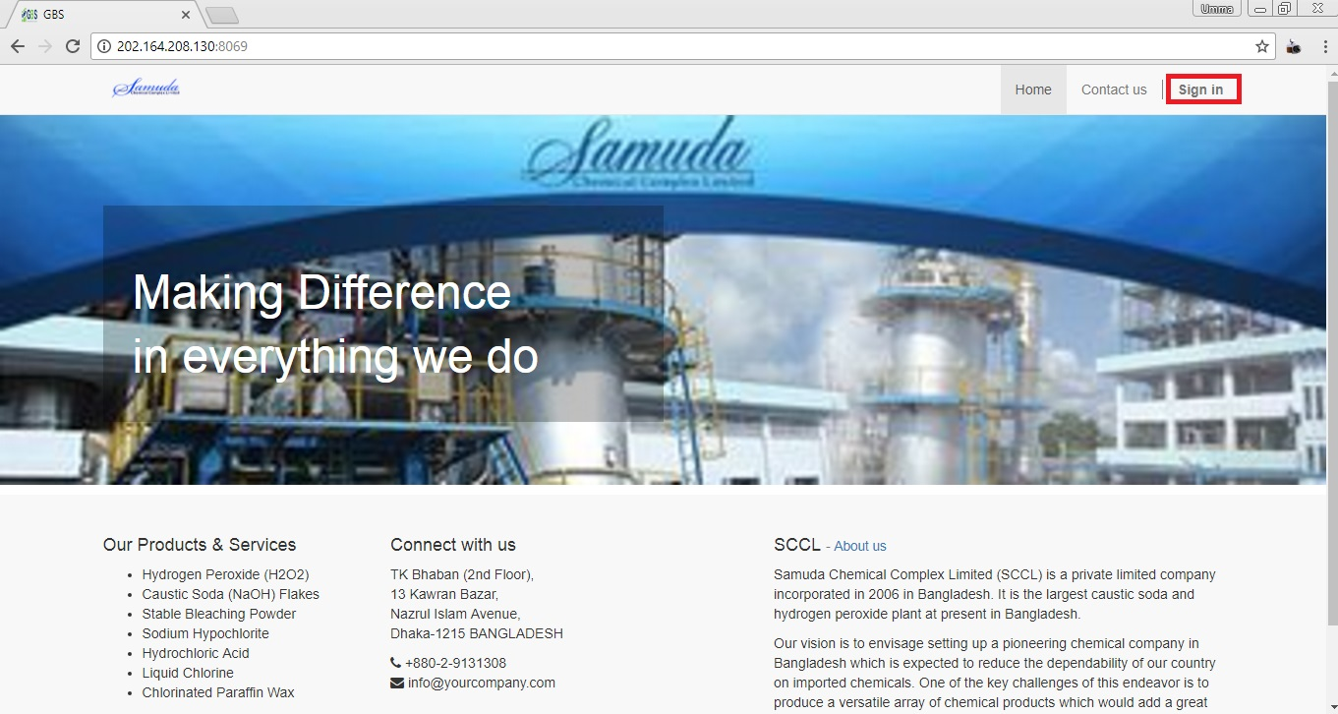

Fig: Home Page

## 1.2 Login Page

After click on sign in button, fill Email and Password -> Click **Log in** button.

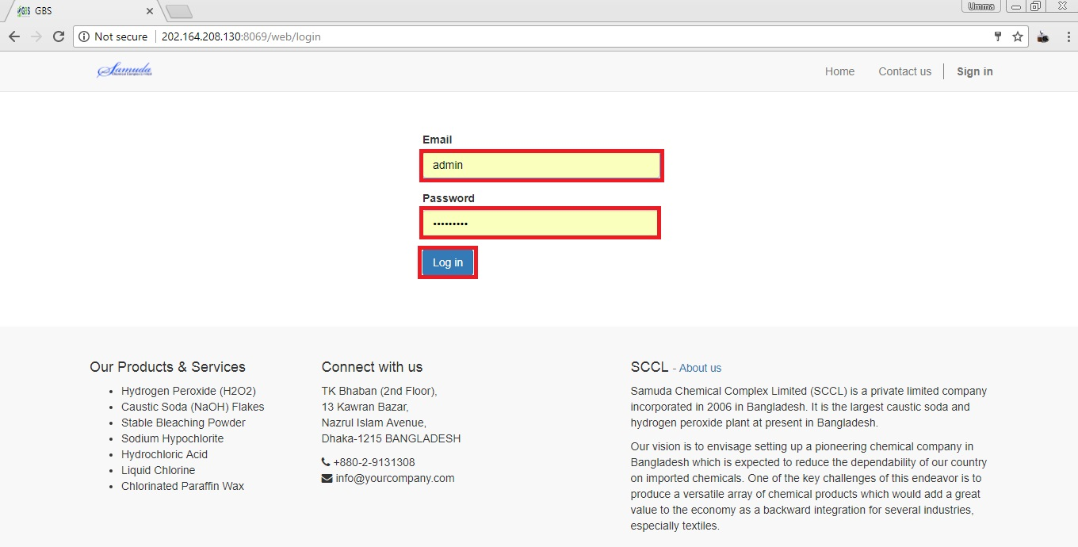

Fig: Login Page

## 1.3 Log out Page

If we want to sign out from website then click **User icon** then find out **Log out** button and click.

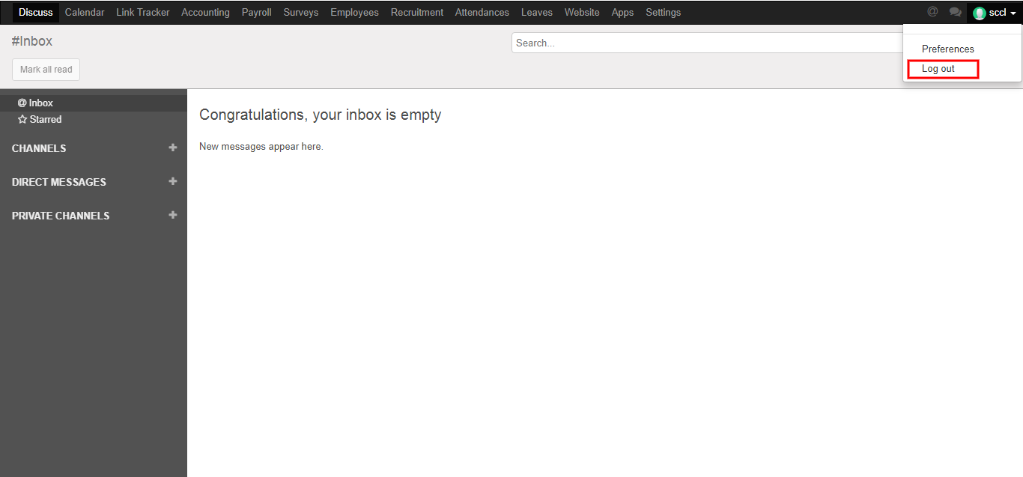

Fig: Logout Page

## 1.4 Edit Profile and Change Password

First we need to click **Preferences** then edit our profile and change our password. After entering the all information click **Save**.

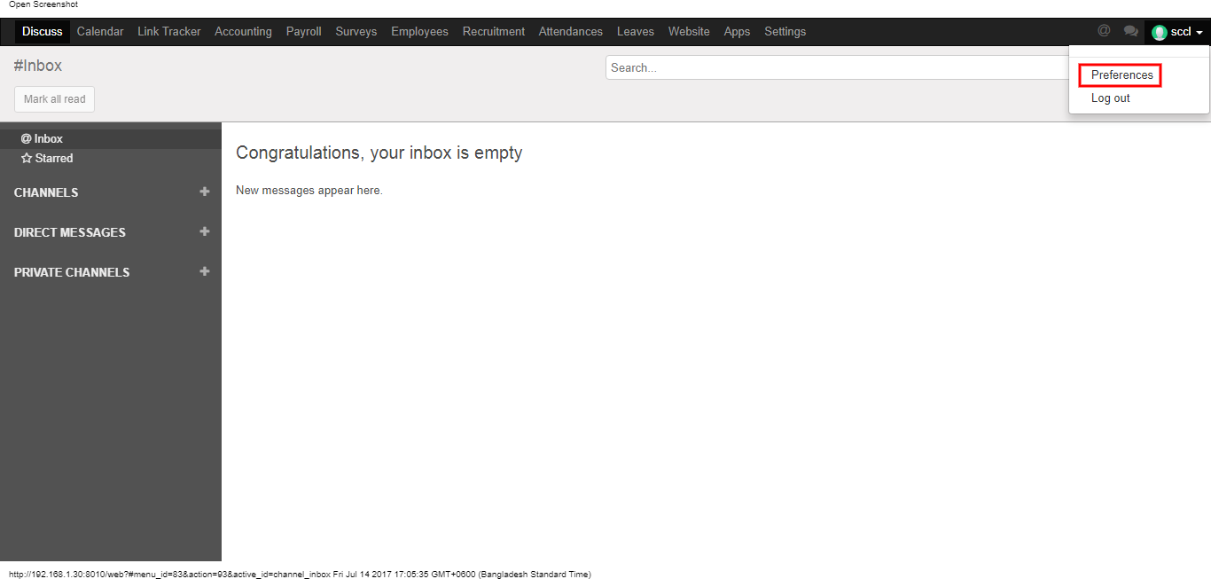

Here we can edit our information what we want. After entering the all information click **Save**.

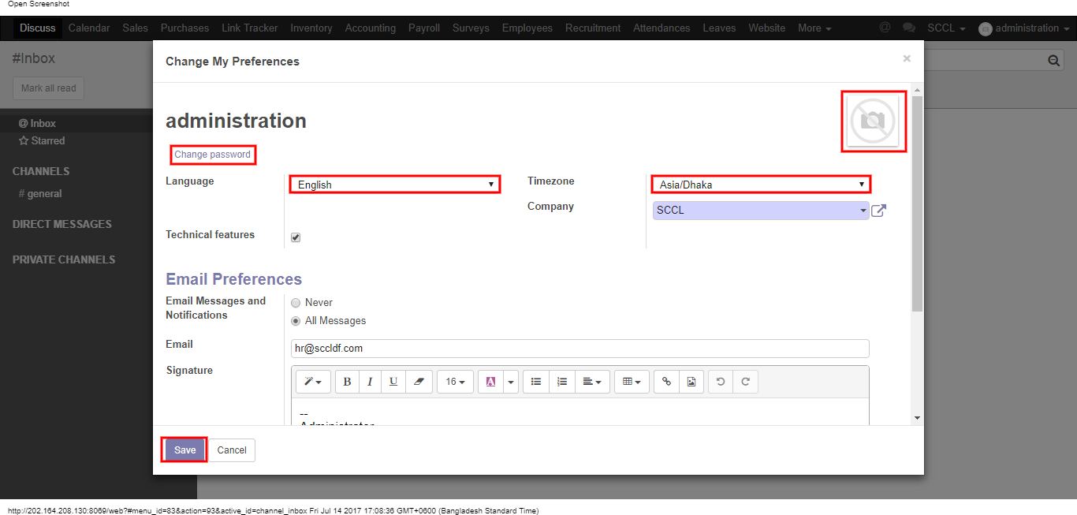

Figure: Edit Profile

Here we can change our own password. First we have to enter our Old Password then enter New Password & Confirm New Password. After entering the information click **Save**.

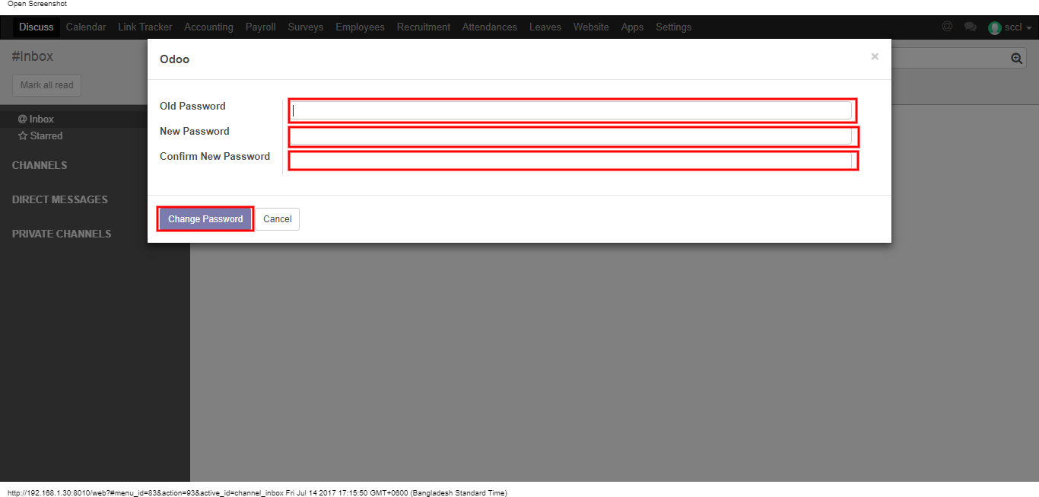

Fig: Change Password

## 1.5 Website Browse and Back to Home Page

Using the menu click **Website** and go to website page and to back click **Website button** then click any menu.

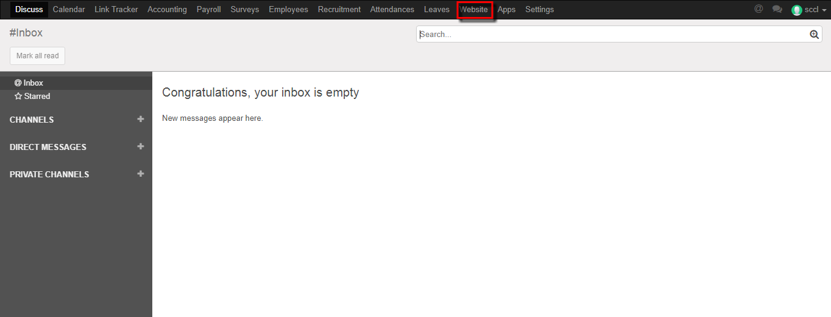

Fig: Go to Website Page

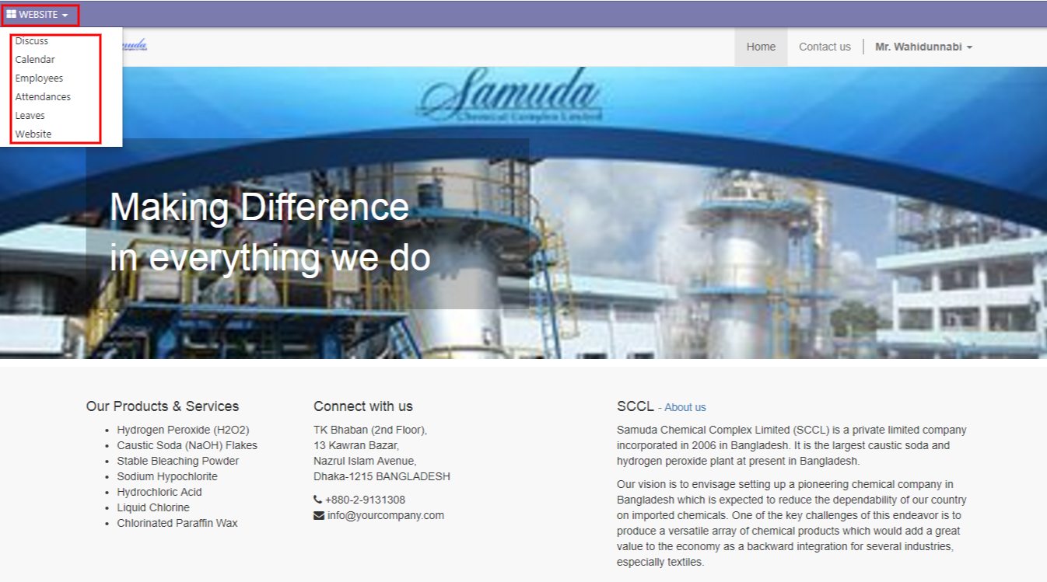

Fig: Back from Website Page

# 2. Leave Request

## 2.1 Create Leave Request

For create a leave request we have to go leave menu then create a leave request.

Using the menu **Leave ‣ My Leaves ‣ Leave Request** click **Calendar** button.

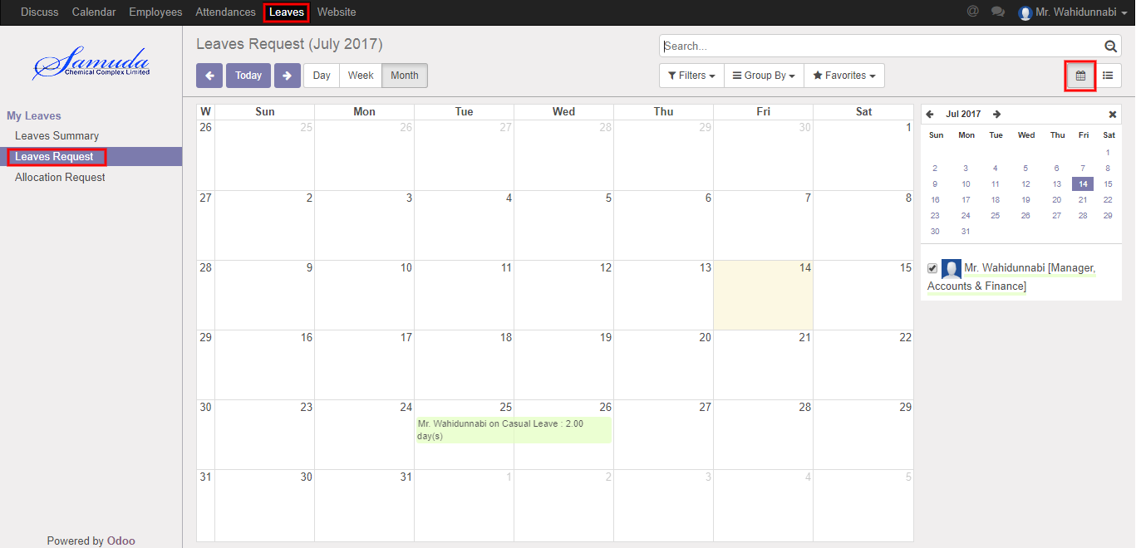

**Fig:** Leave Calendar View

Also we can see using the menu **Leave ‣ My Leaves ‣ Leave Request** click **List** button.

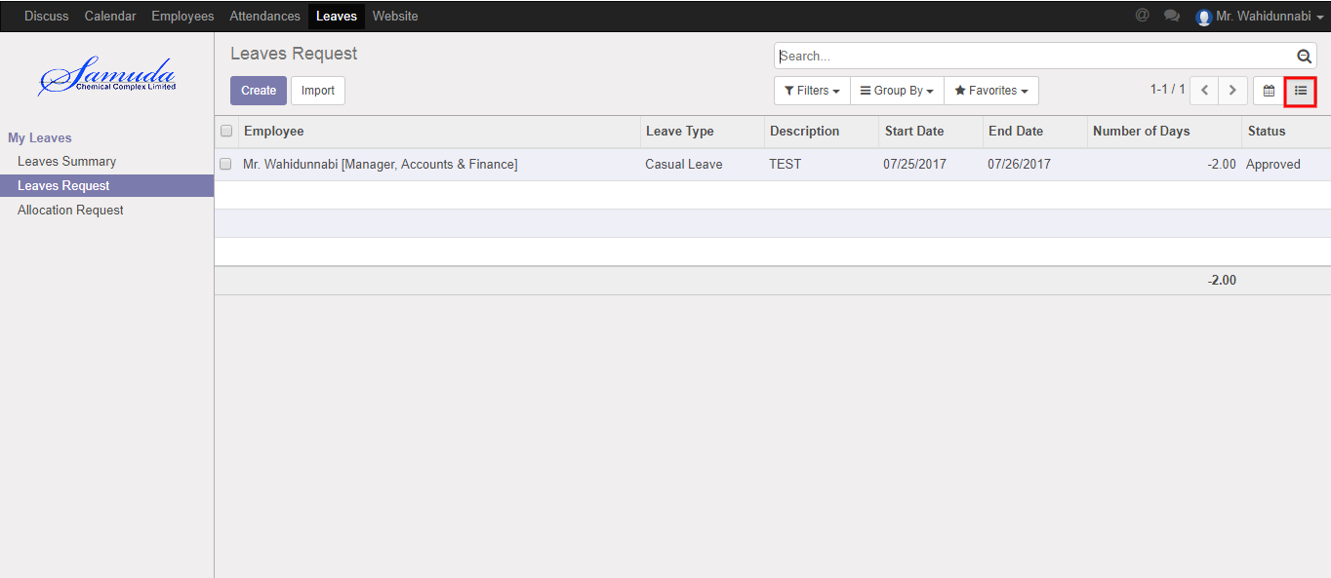

Figure**:** Leave List View

To create new Leave Request, Using the menu **Leave ‣ My Leaves ‣ Leave Request** click **Create**.

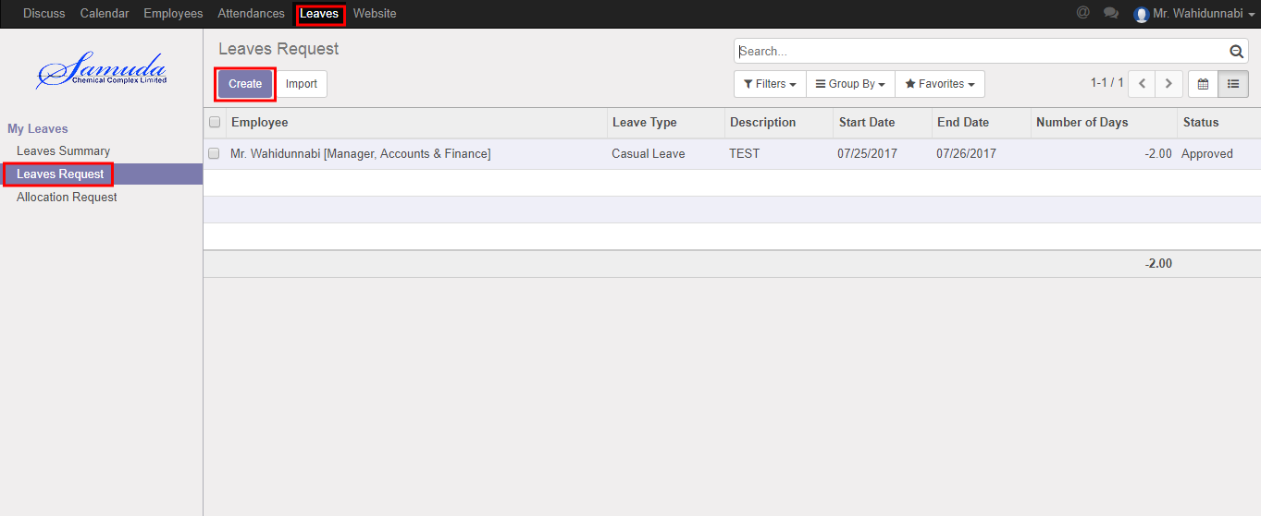

You can set the following information:-

**Description:** Enter some description.

**Leave Type:** Select a leave type.

**Duration:** Select duration of leave.

After entering the Leave Request information click **Save**.

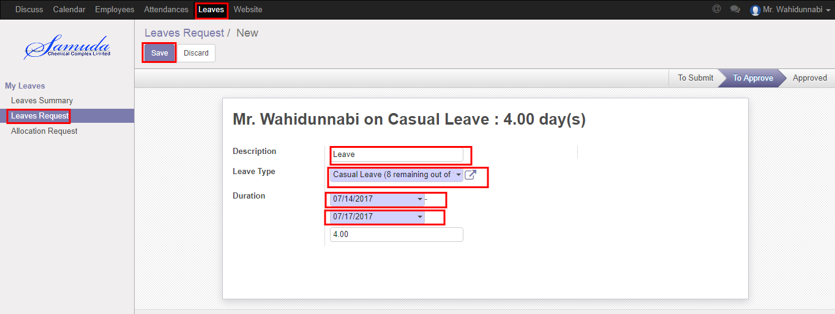

Figure: Create a Leave Request

After apply the leave request “Manager” will get the notification. Manager can Approve the leave request. He can update number of leave day(s) before approval. After Manager Approval, HR will get notification. HR Manager Can Approve or Refuse the leave request. After that requested leave will finally approve.

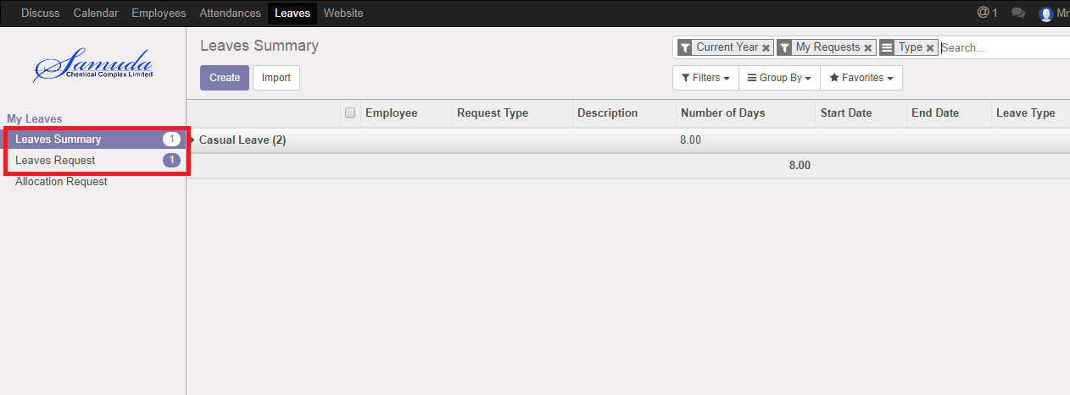

Figure: Leave Request Notification

## 2.2 Show Leave Summary

Using the menu **Leave ‣ My Leaves ‣ Leave Summary**.

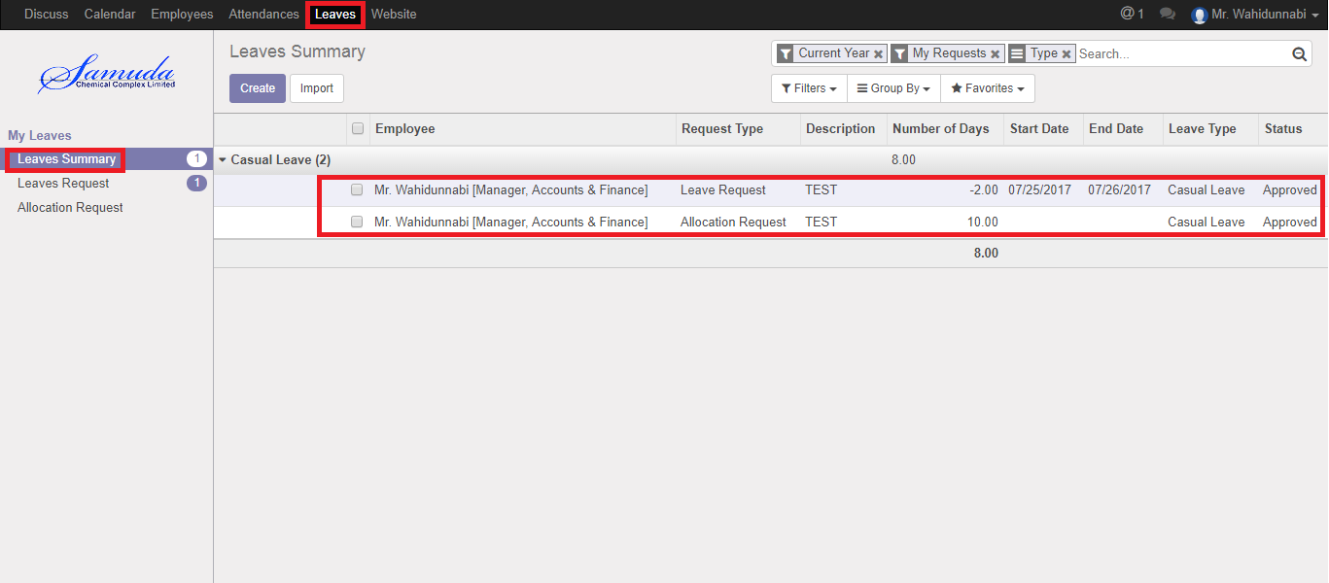

Figure: Leave Summary List View

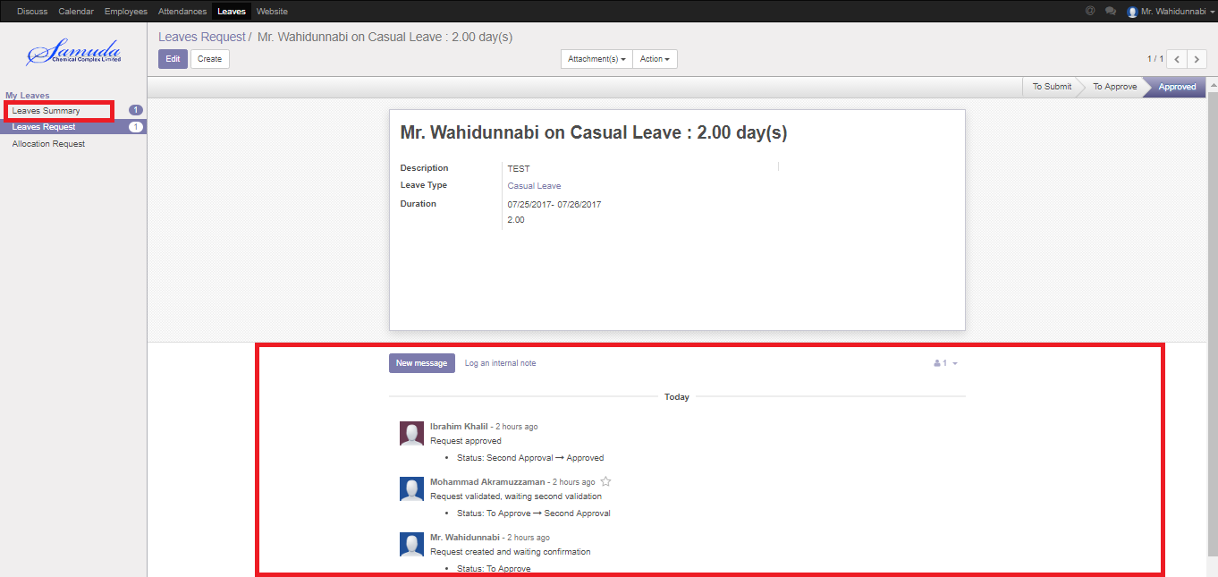

Figure: Leave Summary

## 2.3 Create Leave Allocation Request

For create a leave allocation request we have to go leave menu then create an allocation request.

Using the menu **Leave ‣ My Leaves ‣ Allocation Request** click **Create**.

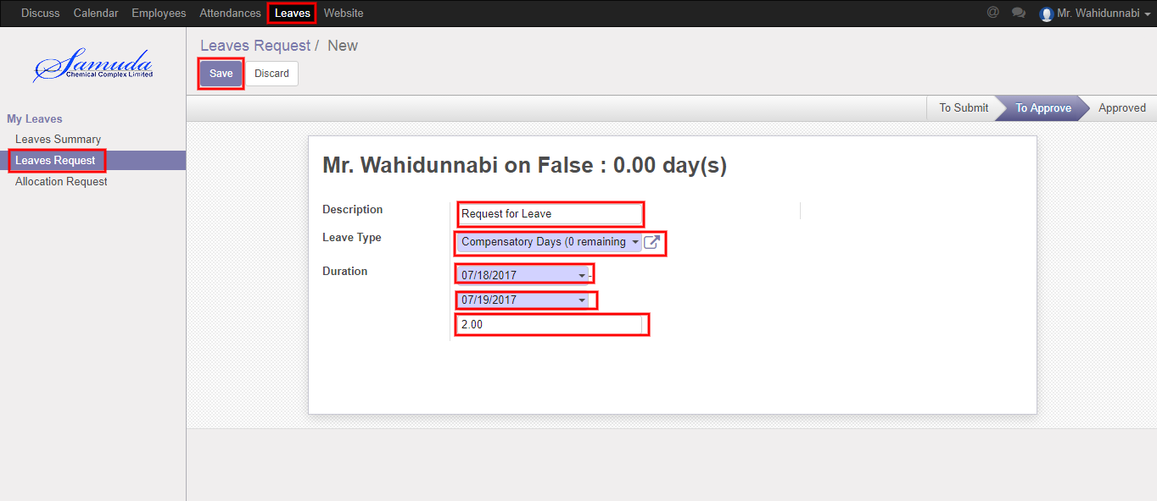

Figure: A Leave Allocation Request

After apply the leave allocation request “Manager” will get the notification. Manager can Approve or Refuse the leave allocation request. He can update number of day(s) before approval. After Manager Approval, HR will get notification. HR Manager Can Approve or Refuse the leave allocation request. After that requested leave allocation will finally approve.